**For: Organisation Name**

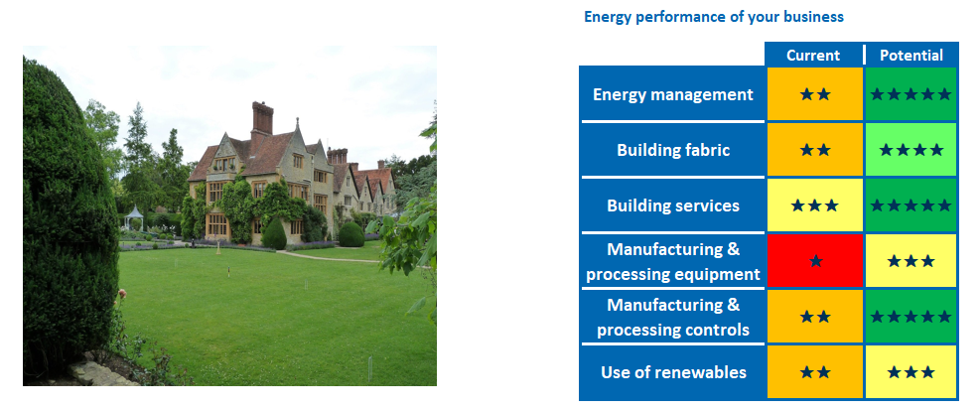

Compare your organisation’s current and potential energy costs, before and after implementing the recommended actions identified below:

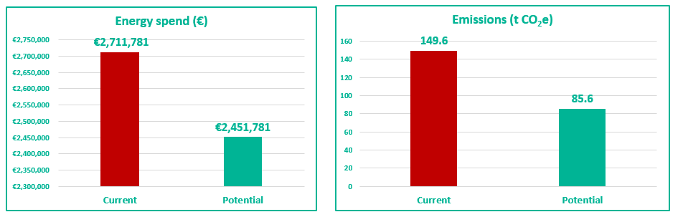

Recommended actions below will help reduce your organisation’s emissions by XXXX% and annual energy spend by €XXX.:

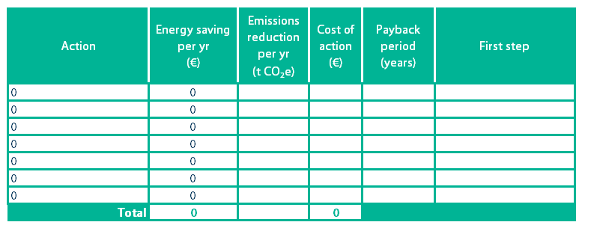

Support Scheme for Energy Audits (SSEA)

Energy Audit Report



**Notice for Applicants**

This Energy Audit Report was prepared by a Registered Energy Auditor and recommends practical ways that you can improve the energy performance of your business, using information gathered from an assessment of your business’s current energy performance. Please seek professional advice before undertaking any energy upgrade works.

Contents

1 Site description 2

Table 1a: Site information 2

Table 1b: Visit information 2

2 What fuels do you use? 3

Table 2a: Energy consumption onsite 3

3 Understanding your energy bills 1

Table 3a: Energy bills analysis 1

4 Electricity, heat and transport 3

Table 4a: Significant Electrical Energy Users 3

Figure 4b: Significant Thermal Energy Users 4

Table 4c: Significant Transport Energy Users 4

5 Energy Management 6

Figure 5a: Energy management scores 6

6 Taking action 7

Table 6a Actions already taken 7

Table 6b: Impact of Renewable Heat 8

Table 6c: Impact of solar photovoltaics 8

Table 6d Recommended actions 9

Appendix A – Site tour checklist 10

Appendix B – Benchmarking 11

Appendix C – Energy Management matrix 12

Appendix D – Renewable Heat Assessment 13

Appendix E – Solar photovoltaic assessment 15

Appendix F – Glossary of terms 16

Appendix G – Completion of Works form 17

1. Site description

This section provides an overview of your site and key information about the visit. A site tour checklist is provided in Appendix A.

|  |  |
| --- | --- |
| Organisation name | XXXX placeholder table XXXX |
| Site address |  |
| County |  |
| Eircode |  |
| Gross floor area (m2) |  |
| No. of personnel working at site |  |
| Is shift work carried out onsite? |  |
| Size of company fleet (no. of vehicles) |  |
| Typical operating hours per year |  |
| Sector |  |
| Build date (estimate if necessary) |  |
| Facility owned or leased |  |

Table 1a: Site information

|  |  |
| --- | --- |
| SEAI Application ID | XXXX placeholder table XXXX |
| Site Visit Date |  |
| MPRN Number |  |
| GPRN Number |  |
| Site Contact name |  |
| Site Contact job title |  |
| Energy Auditor name |  |
| Energy Auditor company |  |
| Comments |  |

Table 1b: Visit information

1. What fuels do you use?

A breakdown of the different types of energy used at your site is shown below in Table 2a.

The energy that a business uses can come from a variety of different sources, for example: electricity that is imported to the site from the grid and used for lighting and appliances, natural gas used for heating the building, and diesel to fuel the fleet.

The table below shows you where your business's energy comes from: the annual cost, how much you use in kilowatt hours (kWh) and how many tonnes of CO2 emissions it generates each year. The information has been taken either from your energy bills (more accurate) or it could be an estimate based on information you have given the Auditor (less accurate).

|  |  |  |  |  |
| --- | --- | --- | --- | --- |
| Reference year: | | | XX placeholder table XXXX | |
| Energy source | Annual Cost  (€) | Annual Use  (kWh) | Annual Emissions  (t CO2e) | Information source |
|  |  |  |  |  |
|  |  |  |  |  |
|  |  |  |  |  |
|  |  |  |  |  |
|  |  |  |  |  |
|  |  |  |  |  |
|  |  |  |  |  |
|  |  |  |  |  |
|  |  |  |  |  |
|  |  |  |  |  |
|  |  |  |  |  |
| Total | € - | - | 0.00 |  |

Table 2a: Energy consumption onsite

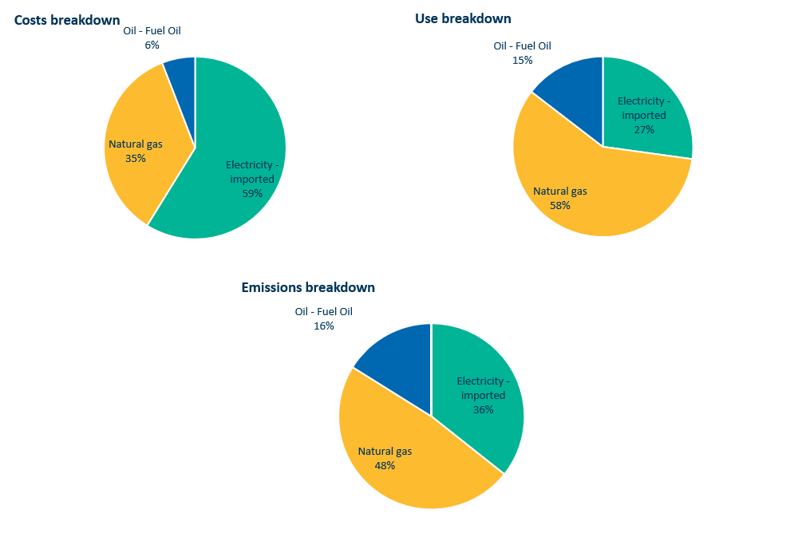

**Figure 2: Breakdown of Costs, Usage and Emissions**

# Site energy consumption summary

XXXX If required, please summarise the information in Table 2a and Figure 2. Comment on anything unusual. XXXX

These graphs illustrate the information from the table above. You may find them useful when making your business case for investing in energy management measures.

1. Understanding your energy bills

The auditor analysed your energy bills to determine whether there are easy changes you can make to help you save money.

|  |  |  |  |
| --- | --- | --- | --- |
|  |  | Yes/No | Comments |
| Is the client on an appropriate tariff/tariffs? | |  | XXX placeholder table XXX |
| Is max import capacity correct for client's requirements? | |  |  |
| Are there any other penalties? | |  |  |
| Comment on day/night/weekend profiles | | |  |
| Comment on any trends or anomalies in the data | | |  |
| Has the client switched their electricity and/or gas contracts in the past 2 years? | | |  |
| Any other comments | | |  |

Table 3a: Energy bills analysis

# Bills analysis summary

XXXX please summarise any recommendations for the client regarding their energy bills and tariffs. If none, make statement to the effect “Client appears to be on the correct tariff, based on their usage. A reassessment should be made in 12 months’ time to check that no unnecessary charges have been added, or if any of the usage profiles have changed significantly.” XXXX

# Monthly trends in energy use

Your energy use may change over the course of the year, for example your use of heating fuel may be higher in the winter months. Figure 3a shows the trends in use for Electricity, Gas and XXX Other Fuel XXXX.

XXX Placeholder graphs XXX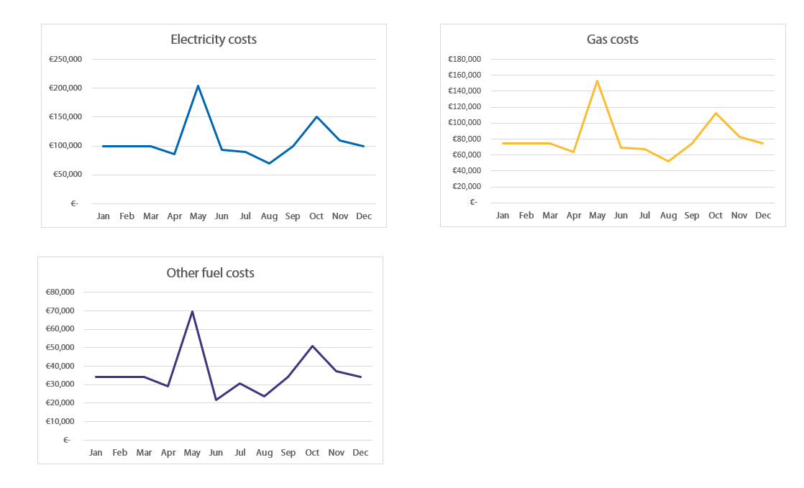

**Figure 3a: Monthly trends in energy use**

# Monthly trends summary

XXX If required, please summarise the graphs, commentating on any trends or anomalies in the data XXX

1. Electricity, heat and transport

The most significant electricity, thermal (heat) and transport energy users at your site have been identified and are listed below.

|  |  |  |  |  |  |  |  |
| --- | --- | --- | --- | --- | --- | --- | --- |
| Energy User | Cost per yr (€) | Usage per yr (kWh) | Usage  (% of total) | Emissions per yr (t CO2e) | Comments | | |
| XXX Placeholder table XXX |  |  |  |  |  | | |
|  |  |  |  |  |  | | |
|  |  |  |  |  |  | | |
|  |  |  |  |  |  | | |
|  |  |  |  |  |  | | |
|  |  |  |  |  |  | | |
|  |  |  |  |  |  | | |
|  |  |  |  |  |  | | |
|  |  |  |  |  |  | | |
|  |  |  |  |  |  | | |
| Total | € | - | 0% | 0.00 |  |  |  |

1. Significant Electrical Energy Users

|  |  |  |  |  |  |  |  |  |
| --- | --- | --- | --- | --- | --- | --- | --- | --- |
| Energy User | Cost per yr (€) | Usage per yr (kWh) | Usage  (% of total) | Energy source | Emissions per yr (t CO2e) | Comments | | |
| XXX Placeholder table XXX |  |  |  |  |  |  | | |
|  |  |  |  |  |  |  | | |
|  |  |  |  |  |  |  | | |
|  |  |  |  |  |  |  | | |
|  |  |  |  |  |  |  | | |
|  |  |  |  |  |  |  | | |
| Total | € - | - | 0% |  | 0.00 |  |  |  |

1. Significant Thermal Energy Users

|  |  |  |  |  |  |  |  |
| --- | --- | --- | --- | --- | --- | --- | --- |
| Vehicle type | Number of vehicles | Fuel type | Fuel cost per yr (€) | Usage per yr (litres) | Usage per yr (kWh) | Emissions per yr (t CO2e ) | Usage  (% of total) |
| XXX Placeholder table XXX |  |  |  |  |  |  |  |
|  |  |  |  |  |  |  |  |
|  |  |  |  |  |  |  |  |
|  |  |  |  |  |  |  |  |
|  |  |  |  |  |  |  |  |
|  |  |  |  |  |  |  |  |
| Total | - |  | € - | 0 | 0 | 0 | 0% |

1. Significant Transport Energy User

# Where is your money going?

XXXX @Auditors: briefly summarise the information in Tables 4a – 4c, e.g. What are the top 3 highest energy users in terms of expenditure, kilowatt hours and emissions, plus anything else of note. XXXX.

1. Energy Management

The aim of Energy Management is to reduce energy use and improve energy efficiency. A structured approach to energy management that includes every aspect of an organisation – including finance, human resources, maintenance, purchasing and planning – is more likely to achieve significant, long-term savings than an unstructured, ad hoc approach.

An “energy management diagnostic” was carried out at your site. The purpose of the diagnostic is to assess your organisation’s approach to energy management, looking at 6 aspects of energy management and ranking each on a scale from 0 – 4.

|  |  |  |
| --- | --- | --- |
| **Aspect of Energy Management** | **Description** | **Your score** |
| **Energy Policy** | Whether your business has an energy policy, and the level of commitment to it | 1 |
| **Organisation** | The extent to which energy management is supported by senior management | 1 |
| **Communication** | How, and how often, staff are informed about energy issues | 2 |
| **Information systems** | How your business monitors energy consumption | 0 |
| **Marketing** | How staff are made aware of the benefits of energy management | 3 |
| **Investment** | How your business makes decisions around investing in energy efficiency | 4 |

Figure 5a: Energy management scores

To view the complete diagnostic showing the various levels, please refer to Appendix B.

# Site Energy Management Summary

XXXX @Auditors: please summarise the information in the diagnostic:

* what are the strengths and weaknesses of the company’s current energy management plan?
* What the client should do to improve their energy management – take from diagnostic XXXX

1. Taking action

# Actions already taken

Before getting this energy audit, you had already taken action to save energy at your site. Changes that you have already made, and the impact they have had, are listed in Table 6a below.

|  |  |  |
| --- | --- | --- |
| Completed actions | Estimated impact (kWh) | Comments |
|  |  |  |
|  |  |  |
|  |  |  |
|  |  |  |
|  |  |  |
|  |  |  |

1. Actions already taken

# Recommended actions to save energy

Your Auditor reviewed potential actions that your organisation can take to improve energy efficiency and generate renewable energy at your facility (specifically, through heat pumps, biomass, and photovoltaics). A list of actions is provided in Table 6a. Many organisations are interested in opportunities for generating renewable energy. a summary of your facility’s suitability for both renewable heating and renewable electricity (solar) is provided below and in Appendices D and E.

## 6.2a Renewable Energy – heating

SEAI’s Support Scheme for Renewable Heat supports renewable heating in businesses by offering a grant for heat pumps and a tariff for biomass/biogas boilers and CHP. As part of this audit, the auditor assessed your facility’s suitability for converting to renewable heat. A brief summary of this assessment is provided below. The complete renewable heat assessment tool may be found in Appendix D. Further information about the scheme may be found on the website[1] or by emailing [SSRH@seai.ie](mailto:SSRH@seai.ie)

Summary of facility’s suitability for renewable heat: XXXX

|  |  |
| --- | --- |
| Overall suitability of the facility for renewable heat. | XXX Placeholder table XXX |

Impact of Renewable Heat: XXX delete if not applicable XXXX

|  |  |
| --- | --- |
| **If facility is suitable for renewable heat:** | |
| Estimated annual kWh savings |  |
| Type of energy saved |  |
| Estimated emissions saved (tCO2e) |  |

1. Impact of Renewable Heat

## 6.2b Renewable Energy – photovoltaics (solar)

Photovoltaics generate electricity using solar energy from the sun, providing a completely renewable, clean source of electrical energy. As part of this audit, the auditor assessed your facility’s suitability for generating electricity from solar energy. A brief summary of this assessment is provided below. The complete photovoltaic assessment tool may be found in Appendix E.

Summary of facility’s suitability for photovoltaics: XXXX

|  |  |
| --- | --- |
| Overall suitability of the facility for solar PV |  |

Impact of solar PV: XXX delete if not applicable XXXX

|  |  |
| --- | --- |
| If facility is suitable for solar PV: | |
| Estimated annual kWh savings |  |
| Estimated emissions saved (tCO2e) |  |

1. Impact of solar photovoltaics

# Recommended actions

Your auditor has identified the top actions you should take to improve the energy efficiency of your site and save on your energy costs. These actions are listed in Table 6d below.

|  |  |  |  |  |  |  |  |  |
| --- | --- | --- | --- | --- | --- | --- | --- | --- |
| Description | Energy savings  (kWh per yr) | Type of energy saved | Cost savings (€ per yr) | Emissions reduction (t CO2e per yr) | Estimated cost of action (€) | Payback period (years) | Potential supports | Comments / Additional info |
| XX placeholder table XX |  |  |  |  |  |  |  |  |
|  |  |  |  |  |  |  |  |  |
|  |  |  |  |  |  |  |  |  |
|  |  |  |  |  |  |  |  |  |
|  |  |  |  |  |  |  |  |  |
|  |  |  |  |  |  |  |  |  |
|  |  |  |  |  |  |  |  |  |
|  |  |  |  |  |  |  |  |  |
|  |  |  |  |  |  |  |  |  |
|  |  |  |  |  |  |  |  |  |

1. Recommended actions

Appendix A – Site tour checklist

The table below shows which areas of your site the auditor checked on during the site visit.

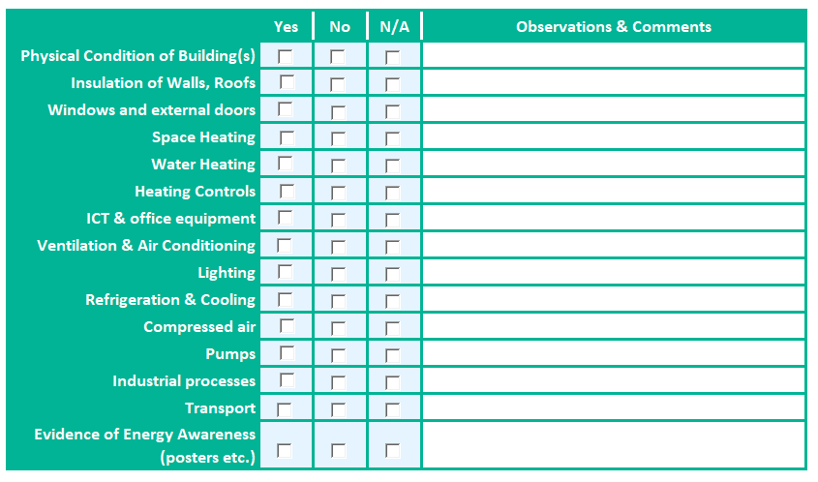

Appendix B – Benchmarking

The table below provides a benchmark of your organisation performance against a range of energy performance metrics, with scores against each for your current and potential. The “potential” score is based on implementation of all the recommendations identified in this report.

XXX Placeholder table XXX

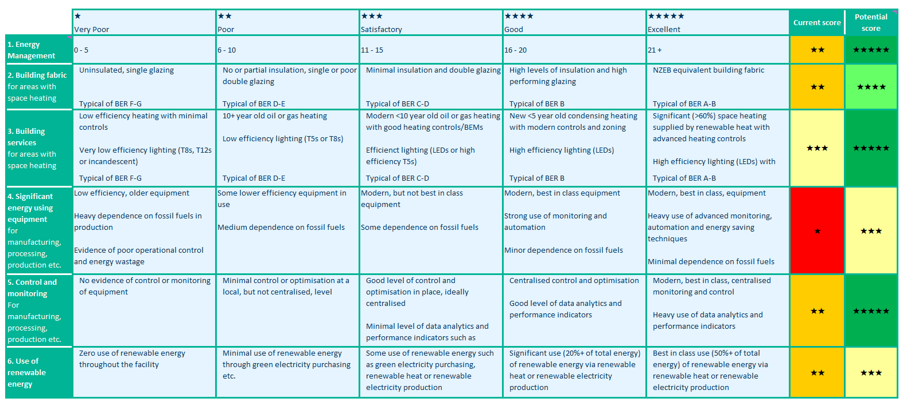

Appendix C – Energy Management matrix

The matrix below shows you how to interpret your Energy Management score. The Scores run from 0 to 4, where 4 is the best. Your facility was assessed according to the 6 aspects of energy management listed across the top. Use this matrix to see what you need to do to improve your Energy Management score.

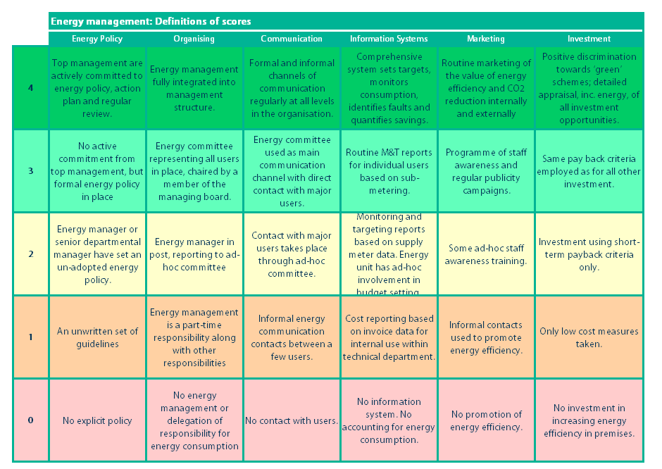

Appendix D – Renewable Heat Assessment

XXX Placeholder table XXX

|  |  |  |
| --- | --- | --- |
|  | Result | Comments |
| Is the client using fossil fuel for heating purposes? |  |  |
| Suitability for heat pump | | |
| Could a heat pump offer an alternative?  e.g. does the facility have a steady low/medium heating requirement? |  |  |
| o   If yes for space heating: Is it likely that the building will achieve the required U values for a heat pump to operate effectively? |  |  |
| o   If yes for space heating: What fabric and ventilation upgrades may be required? If "Other" please specify in Comments |  |  |
| Rank heat pump readiness for space heating:  1 – major upgrades required to all/most building elements,  2- major upgrades required to one building element, 3 – minor upgrades required to all/most building elements,  4 – minor upgrade required to one building element,  5 – heat pump ready |  |  |
| o   If yes for process heating: Is it likely that a heat pump could deliver the heat requirement? |  |  |
| Estimate of emissions reduction for heat pump conversion |  |  |

XXX Placeholder table XXX

|  |  |  |
| --- | --- | --- |
| Suitability for biomass | | |
| Could biomass/biogas offer an alternative? i.e. does the facility have high peak loads? |  |  |
| o If yes, are there any space constraints,  e.g. for the boiler/CHP unit, and the delivery and/or storage of fuel? If "other" please specify in comments |  |  |
| o If yes, are there any local supply of waste biomass or local biomass enterprises that can provide fuel stock? Please specify in comments |  |  |
| o If yes, are there dedicated maintenance personnel on site? |  |  |

Appendix E – Solar photovoltaic assessment

XXX Placeholder table XXX

|  |  |  |
| --- | --- | --- |
| Suitability for solar PV | Result | Comments |
| Does the client use electricity from non-renewable sources? |  |  |
| Does the client appear to have a suitable roof for the installation of solar photovoltaic panels?  Consider size, tilt angle, orientation and shading. |  |  |
| If the roof is not suitable, is there an alternative location available? |  |  |
| If solar PV is feasible, what is the client's estimated required power output? |  |  |
| Estimate the proportion of the client's electricity requirements that could be met through installing solar PV |  |  |

Appendix F – Glossary of terms

|  |  |
| --- | --- |
| Term | Definition |
| biogas | Biogas is a form of renewable energy. Biogas is produced through the anaerobic digestion or fermentation of organic feedstocks including biomass, sewage and agricultural and municipal wastes. The biogas can then be burnt as a renewable fuel. |
| biomass | Biomass fuel is a form of renewable energy generated from burning organic material such as wood, poultry litter, and straw |
| CHP | Combined Heat and Power: an energy efficient way to generate electricity whilst capturing and using the heat that would otherwise be wasted. |
| CO2e | Carbon dioxide equivalent: a standard unit for measuring emissions by expressing the impact of all greenhouse gases (including carbon dioxide, methane and nitrous oxide) in terms of the amount of carbon dioxide that would create the same amount of atmospheric warming |
| electricity imported | Electricity that has been generated offsite for use at your facility |
| energy efficiency | Using less energy to perform the same task, i.e. reducing energy waste |
| fossil fuel | Carbon-based fuels from fossil hydrocarbon deposits, including coal, peat, oil, and natural gas. Fossil fuels produce carbon dioxide (CO2)when burned, which is a greenhouse gas |
| GPRN | Gas Point Registration Number (GPRN): a unique reference number assigned to every gas point on the natural gas network. A gas point is a point where gas is taken from the gas network system, measured by a meter and consumed by an end user. Each individual gas point has its own GPRN. GPRNs have up to 7 digits. |
| heat pump | Electrical devices which convert energy from the air outside of your home into useful heat, in the same way a fridge extracts heat from its inside. Different types of heat pump draw heat from different sources: air, water or the ground. |
| kWh | Kilowatt hour: a unit of energy, equivalent to operating a 1,000 watt appliance running for one hour. |
| LPG | Liquefied Petroleum Gas is manufactured in oil refining, crude oil stabilisation and natural gas processing plants and consists of propane and/or butane gases. Typically used in boilers and for cooking. |
| Maximum Import Capacity (MIC) | The upper limit on the total electrical demand that a consumer can place on the network system. |
| MPRN | A Meter Point Reference Number (MPRN) is a unique 11-digit number assigned to every single electricity connection and meter in the country. Each individual meter has its own MPRN. |
| natural gas | Natural gas is a naturally occurring fossil fuel that is composed mainly of methane. It is piped through a national gas transmission & distribution network (in gaseous form, under pressure) directly to end users in the industrial, power generation, services and domestic sectors. |
| renewable energy | Energy from renewable non-fossil fuel sources, e.g. wind, solar (both solar thermal and solar photovoltaic) and geothermal energy, ambient energy, tide, wave and other ocean energy, hydropower, biomass, and biogas |
| solar photovoltaics | Also called “solar PV”, solar panels that generate electricity when exposed to sunlight |
| thermal energy | Thermal energy refers to all solid, liquid and gas fuels used for non-transport purposes. This includes both fossil and renewable fuels used in boilers, space & process heating systems, catering, fuel-based electricity generators (onsite), CHP and in all plant, equipment & other non-road mobile vehicles. |

Appendix G – Completion of Works form

|  |  |
| --- | --- |
| A. Audit Details | |
| Business/Organisation Name |  |
| Applicant SSEA ID |  |
| Facility MPRN |  |
| Facility Address |  |
| Facility Eircode |  |

|  |  |
| --- | --- |
| B. Auditor declaration | |
| By signing this Completion of Works, the undersigned states that:   * The Energy Audit carried out at the above Facility Address has been delivered according to the SSEA Terms and Conditions and SSEA Guidance for Auditors. * The information provided in this Energy Audit is true and correct to the best of my knowledge. | |
| Signed |  |
| Date |  |
| Name |  |
| Date SSEA site visit was carried out |  |
| Total cost of this SSEA Energy Audit, including the Voucher |  |

|  |  |
| --- | --- |
| C. Applicant declaration: | |
| By signing this Completion of Works, the undersigned states on behalf of the Business/Organisation named above that:   * A visit to the above Facility Address was carried on the date referred to in Section B by the Auditor referred to in Section B for the purpose of completing an energy audit, * I have received a copy of the SSEA Report from the Auditor, * I understand the Report’s findings, and * I am satisfied with the site visit and with the quality of the Energy Audit Report | |
| Signed |  |
| Date |  |
| Name |  |
| Title/Position in Business/Organisation* |  |

* Must be signed by a Director or Senior Manager (or equivalent level) of the business/ organisation referenced below.

NOTE: This Completion of Works form should be returned with all other completed documents relating to this application. If any form is incomplete or missing, then the request for payment will be returned.

**Notice for Applicants**

Applicants please note:

This document was prepared by a Registered Energy Auditor and recommends practical ways that you can improve the energy performance of your business, using information gathered from an assessment of your business’s current energy performance. Please seek professional advice before undertaking any energy upgrade works.

**Sustainable Energy Authority of Ireland**

SEAI is Ireland’s national energy authority investing in, and delivering, appropriate, effective, and sustainable solutions to help Ireland’s transition to a clean energy future. We work with the public, businesses, communities, and the Government to achieve this, through expertise, funding, educational programmes, policy advice, research and the development of new technologies.

SEAI is funded by the Government of Ireland through the Department Environment, Climate and Communications.

© Sustainable Energy Authority of Ireland

Reproduction of the contents is permissible provided the source is acknowledged.

**w:** www.seai.ie

**e:** info@seai.ie

**t:** 01 8082100



1. <https://www.seai.ie/business-and-public-sector/business-grants-and-supports/support-scheme-renewable-heat/>